Supporting Information

Study of the mechanism of nitrogen doping in carbon supports on promoting electrocatalytic oxygen reduction reaction with platinum nanoparticles
SUN Xue-qin ^{1,2}, GAO Xin-hua ³, WANG Ying-yong^{1, *}, and TONG Xi-li ^{1, *}

(1. State Key Laboratory of Coal Conversion, Analytical Instrumentation Center, Institute of Coal Chemistry, Chinese Academy of Science, Taiyuan 030001, China;
2. University of Chinese Academy of Sciences, Beijing 100049, China;
3.NingXia University, Yinchuan 750021, China)

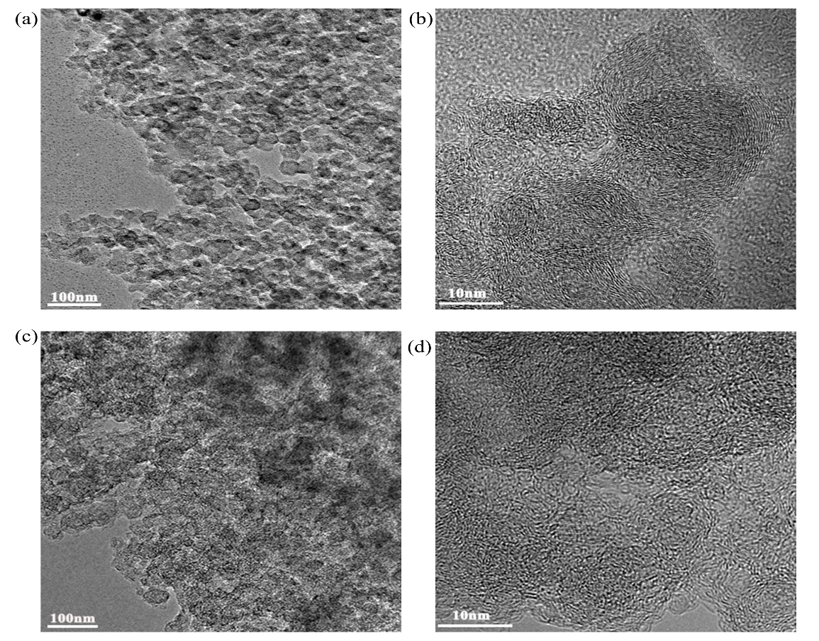

Fig. S1. TEM images of carbon nanoparticle (a. b) and Nano-NC-800 support (c. d).

Fig.S2. XRD patterns of carbon nanoparticles, the Nano-NC-700, the Nano-NC-800, and Nano-NC-900.
(a)

Fig.S3. TEM images of Pt/Nano-C (a) and the corresponding size distribution of Pt nanoparticles of (b).
Fig.S4. LSV of the Pt/Nano-NC-700, Pt/Nano-NC-800, and Pt/Nano-NC-900 catalysts in O₂-saturated 0.1M HClO₄ at a scan rate of 5 mV/s.
Fig.S5. CVs of the Pt/Nano-NC-800, Pt/Nano-C and JM Pt/C catalysts at a scan rate of 50 mV/s in Ar-saturated 0.1M HClO_{4.}
Fig. S6. Mass activity and specific activity of the Pt/Nano-NC-700, Pt/Nano-NC-800, Pt/Nano-NC-900, Pt/Nano-C, and JM Pt/C catalysts at 0.9 V (V vs RHE).

Fig.S7. LSVs in O₂-saturated 0.1 M HClO₄ at different RDE rotation rates and the corresponding Koutecky–Levich plots (insets) of the (a)Pt/Nano-NC-700, (b)Pt/Nano-NC-900, (c)Pt/Nano-C, and (d) JM Pt/C catalysts.

Fig.S8. (a) The RRED curves of Pt/Nano-NC-800;(b) H₂O₂% yield of Pt/Nano-NC-800 and JM Pt/C based on RRED test data.
(b)
(d)
(f)
Fig.S9. LSV of the (a) Pt/Nano-NC-800, (c) Pt/Nano-C, and (e)JM Pt/C catalysts before and after 5000 cycling tests. TEM images of the (b))Pt/Nano-NC-800, (d) Pt/Nano-C, and (f) JM Pt/C catalysts after 5000 cycles.

Fig.S10. LSV of the Pt/Nano-NC-800 and JM Pt/C catalysts before and after 10000 cycling tests.
Fig.S11. Comparison of the specific activity of Pt/Nano-NC-700, Pt/Nano-NC-800, Pt/Nano-NC-900, Pt/Nano-C, and JM Pt/C catalysts after 5000 cycles.

Table S1. BET surface area and pore size of carbon nanoparticles, Nano-NC-700, Nano-NC-800, and Nano-NC-900.
Sample | BET surface area(m² g⁻¹) | Pore Size(nm)
Pt/Nano-C | 1195 | －
Pt/Nano-NC-700 | 1205 | 6.8
Pt/Nano-NC-800 | 1300 | 7.4
Pt/Nano-NC-900 | 1362 | 7.6

Table S2. Results of the fits of the Pt 4f XPS. For each single component, the binding energy (eV) and amount (%) values are given

Sample | Pt⁰ | Pt²⁺ | Pt⁴⁺
Pt/Nano-C | 71.5 eV  24.0% | 72.2 eV  47.9% | 73.6 eV  28.1%
Pt/Nano-NC-700 | 71.7 eV  35.2% | 72.6 eV  41.2% | 74.6 eV  23.4%
Pt/Nano-NC-800 | 71.8 eV  37.8% | 72.4 eV  38.2% | 74.6 eV  24.0%
Pt/Nano-NC-900 | 71.6 eV  33.8% | 72.3 eV  37.5% | 74.3 eV  28.6%

Table S3. Comparison of ORR activity of Pt/Nano-NC-800 catalyst with other catalysts.
Catalyst | Half wave  Potential(V) | Limiting  diffusion current  (mA cm⁻²) | ECSA  (m²g⁻¹) | Sweep rate  (mV s⁻¹) | Electrolyte | Ref
Pt/BG3 | 0.51 | 4.60 | 49.57 | 10 | 0.1M HClO₄ | [1]
Pt/MGTC | ~0.77 | ~6.80 |  | 10 | 0.5M H₂SO₄ | [2]
Pt-CeOxNW/C | 0.69 |  |  | 10 | 0.5M H₂SO₄ | [3]
Pt/TfGnPs | 0.75 | 3.33 |  | 10 | 0.1M HClO₄ | [4]
Pt-Ni(trace)/GNs | 0.76 | 4.36 | 40.94 | 5 | 0.5M H₂SO₄ | [5]
Pt-WP-CL/AEG | 0.61 | 7.01 | 123.05 | 10 | 0.5M H₂SO₄ | [6]
PtP2@PNC | 0.74 | 5.50 | 70 | 5 | 0.1M HClO₄ | [7]
Cu@Pt/NCNT | 0.70 |  | 16.2 | 5 | 0.5M H₂SO₄ | [8]
Pt/N-OHPC | 0.76 | 4.80 | 59.5 | 5 | 0.5M H₂SO₄ | [9]
Pt/Nano-NC-800 | 0.80 | 5.37 |  | 5 | 0.1M HClO₄ | This work
Supporting References
[1] ASHOK R, RAMAPRABHU S. Investigation of catalytic activity towards oxygen reduction reaction of Pt dispersed on boron doped graphene in acid medium[J]. J Colloid Interface Sci, 2016, 479: 260-270.
[2] KIM Y, LEE D, KWON Y, KIM T W, KIM K, KIM H J. Enhanced electrochemical oxygen reduction reaction performance with Pt nanocluster catalysts supported on microporous graphene-like 3D carbon[J]. J Electroanal Chem, 2019, 838: 89-93.
[3] CHANHAN S, MORI T, MASUDA T, UEDA S, RICHARDS G J, HILL J P, ARIGA K, ISAKA N, AUCHTERLONIE G, DRENNAN J. Design of Low Pt Concentration Electrocatalyst Surfaces with High Oxygen Reduction Reaction Activity Promoted by Formation of a Heterogeneous Interface between Pt and CeO(x) Nanowire[J]. ACS Appl Mater Interfaces, 2016, 8(14): 9059-70.
[4] JEON I Y, KWEON D H, KIM S W, SHIN S H, IM Y K, YU S Y, JU M J, BAEK J B. Enhanced electrocatalytic performance of Pt nanoparticles on triazine-functionalized graphene nanoplatelets for both oxygen and iodine reduction reactions[J]. J Mater Chem A, 2017, 5(41): 21936-21946.
[5] LIU Y, LI Z S, XU S H, XIE Y X, YE Y X, ZHOU X H, LIN S. Synthesis of Pt-Ni (trace)/GNs composite and its bi-functional electrocatalytic properties for MOR and ORR[J]. J Colloid Interface Sci, 2019, 554: 640-649.
[6] ZHANG C Y, DAI Y, CHEN H, MA Y Y, JING B J, CAI Z, DUAN Y Q, TANG B, ZOU J L. Carbon-thin-layer protected WP with no passivation supported on acid-treated expanded graphite as efficient Pt Co-catalysts for methanol oxidation and oxygen reduction reactions[J]. J Mater Chem A, 2018, 6(45): 22636-22644.
[7] PU Z H, CHENG R L, ZHAO J H, HU Z Y, LI C F, LI W Q, WANG P Y, AMIINU I S, WANG Z, WANG M, CHEN D, MU S C. Anion-Modulated Platinum for High-Performance Multifunctional Electrocatalysis toward HER, HOR, and ORR[J]. iScience, 2020, 23(12): 101793.
[8] ZHAO Y, LIU R. Cu@Pt/NCNT preparation and electrochemical performance[J]. J Mater Sci Mater Electron, 2021, 32(4): 4214-4227.
[9] LI Y F, WANG D R, XIE H Y, ZHANG C W. Electrocatalytic Activity and Stability of 3D Ordered N‐doped Hierarchically Porous Carbon Supported Pt Catalyst for Methanol Oxidation and Oxygen Reduction Reactions[J]. ChemistrySelect, 2019, 4(43): 12601-12607.

