**Supporting Information**

Directing the CdS nanosheet and nanowire to high efficiency for photocatalytic anaerobic dehydrogenation of benzyl alcohol to benzaldehyde by depositing Au25 nanoclusters

LI Xing-chi1,2#, ZHAO Han1#, PAN Xiao-li1, SU Yang1, LI Ren-gui3,

WANG Hua1, KANG Lei-lei1, LIU Xiao-yan1*

（1. CAS Key Laboratory of Science and Technology on Applied Catalysis，iChEM，Dalian Institute of Chemical Physics, Chinese Academy of Sciences, Dalian 116023, China;

2. University of Chinese Academy of Sciences, Beijing 100049, China;

3. State Key Laboratory of Catalysis, Dalian National Laboratory for Clean Energy, Dalian Institute of Chemical Physics, Chinese Academy of Sciences, Dalian 116023, China)

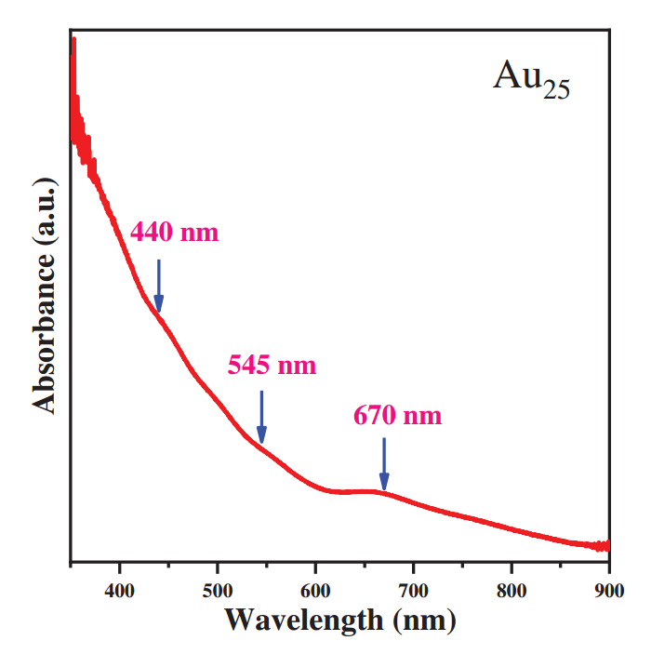

Fig. S1 UV-vis spectra of Au25 clusters

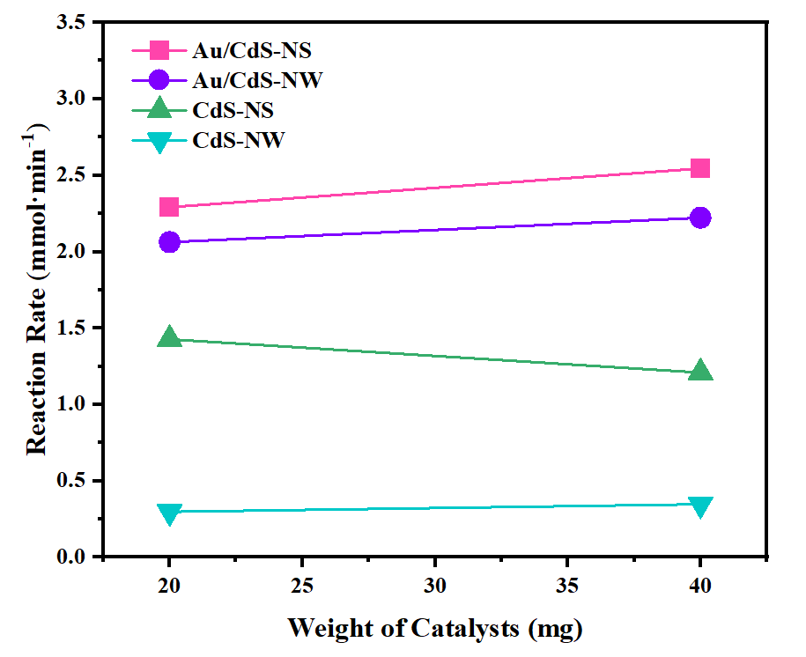

Fig. S2 Reaction Rate of different catalysts change along with the weight of catalysts

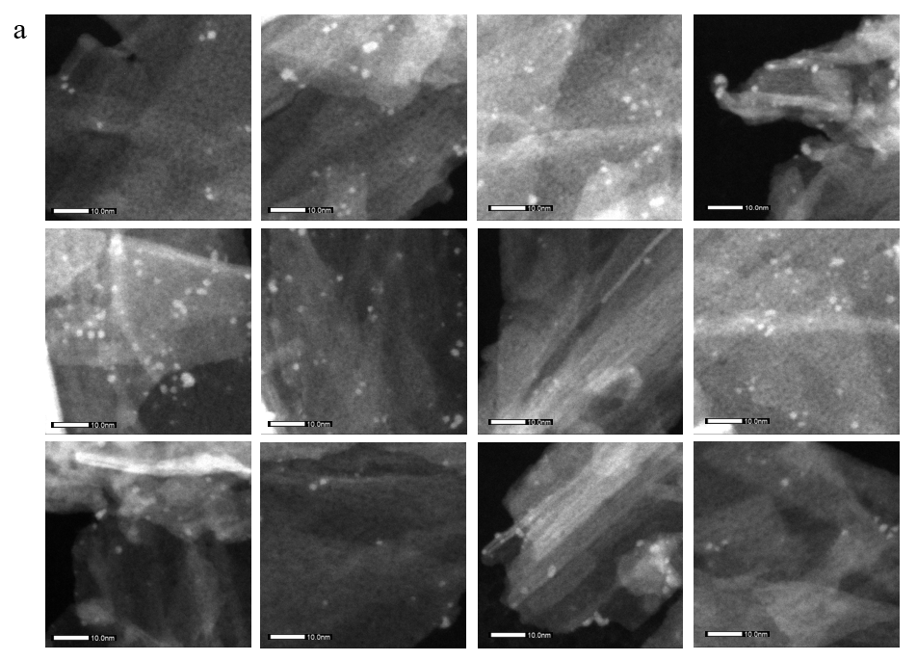

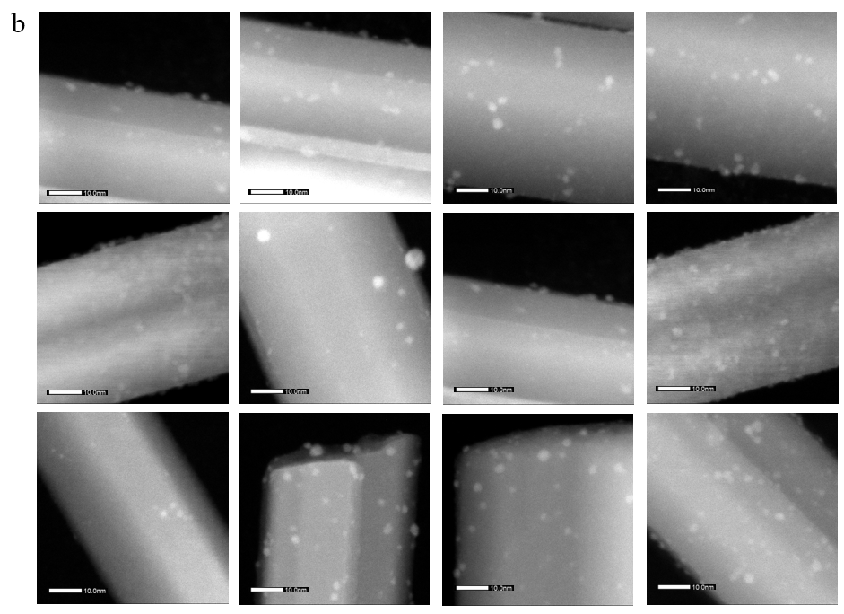

Fig. S3 TEM images of (a) Au25/CdS-NS, and (b) Au25/CdS-NW for calculation of the particle size of Au.

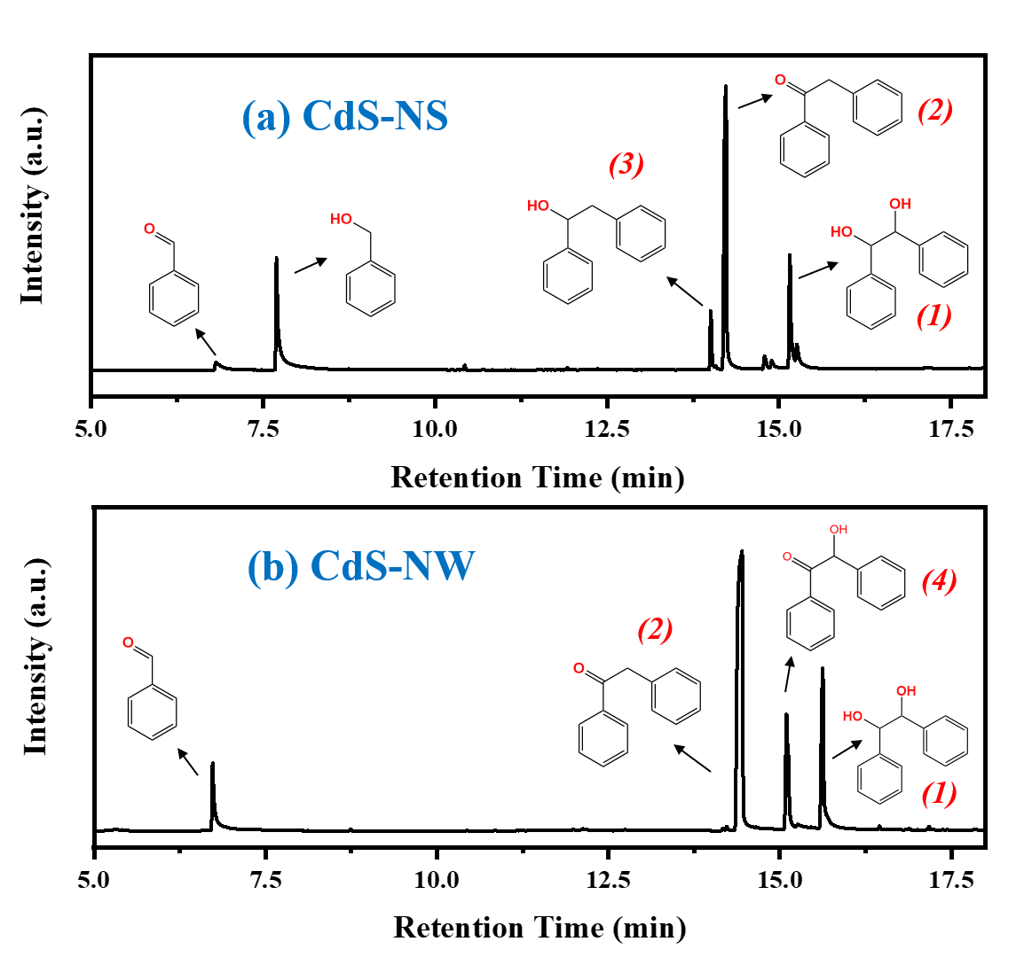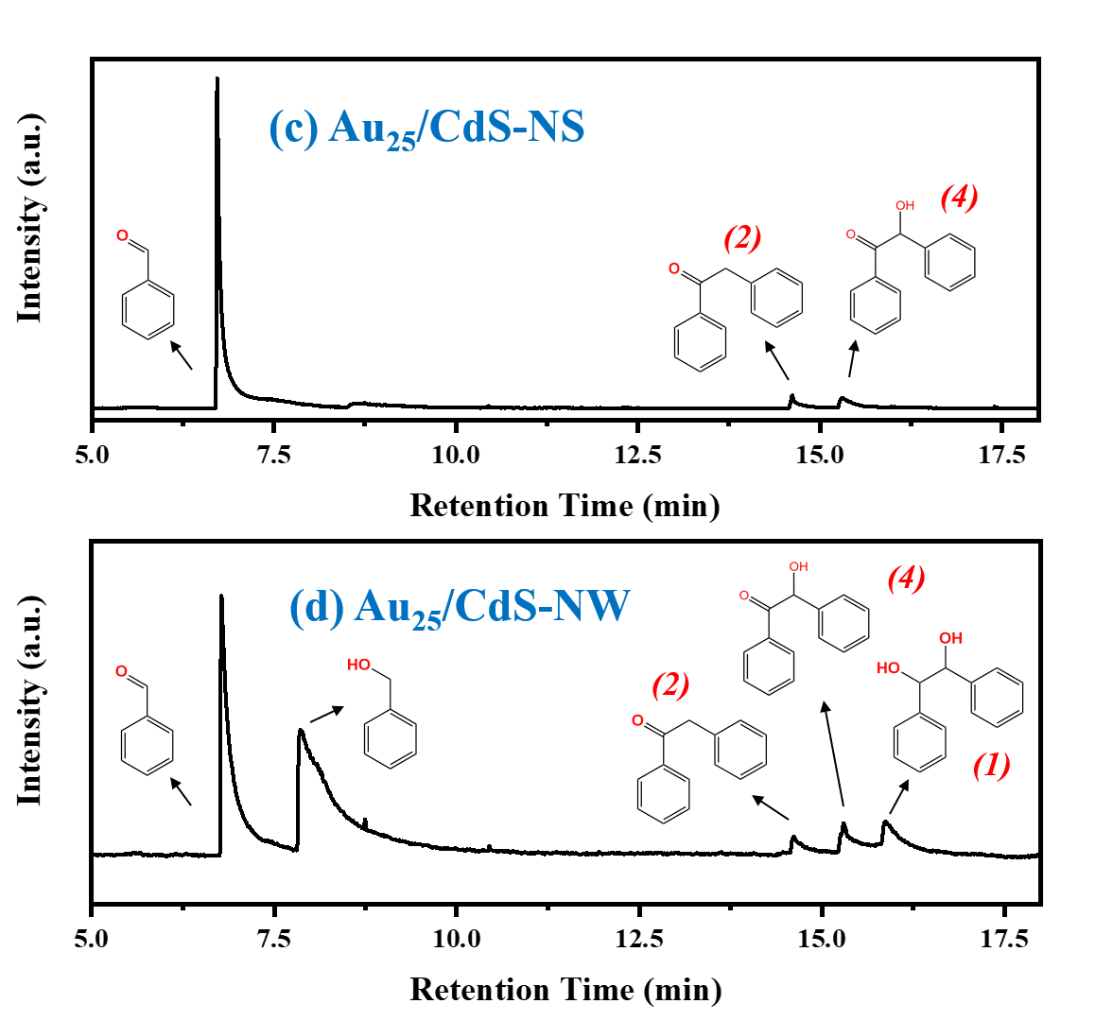

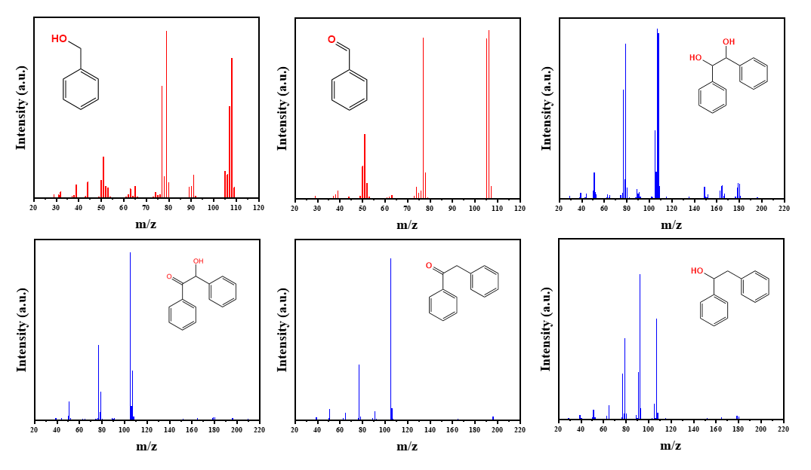

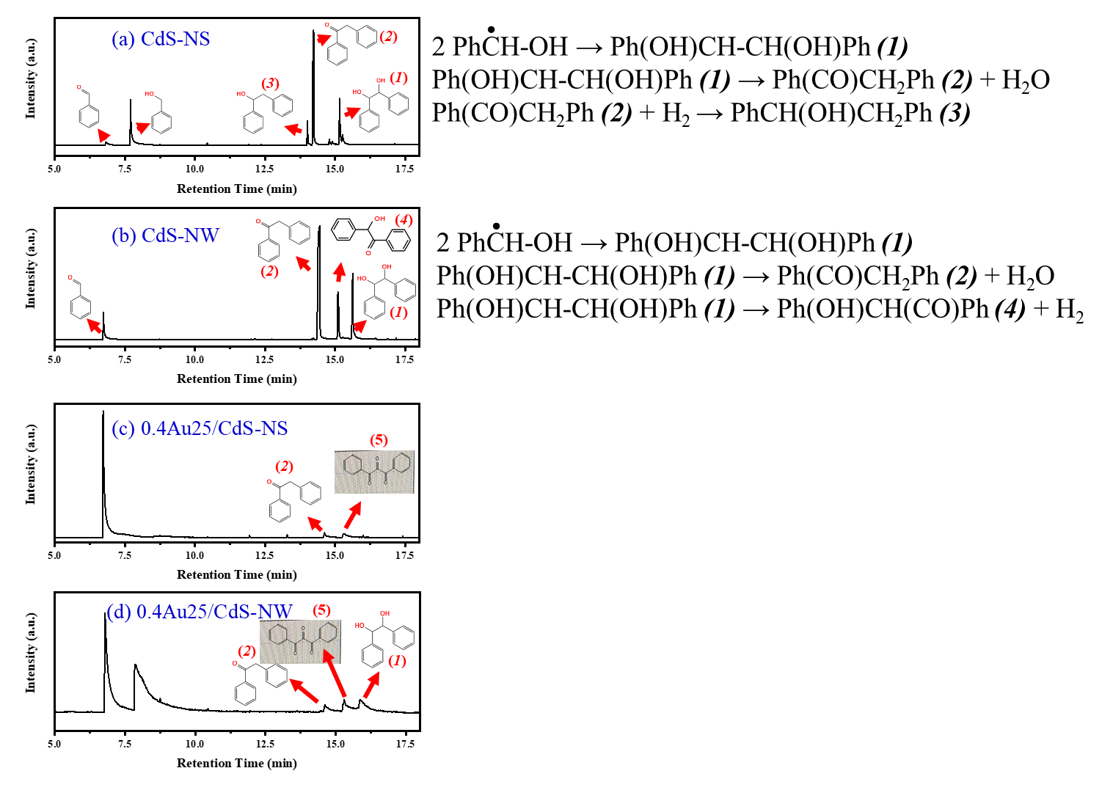

Fig. S4 The TCD signals during the GC-MS test for the catalytic reaction over the different catalysts as indicated.

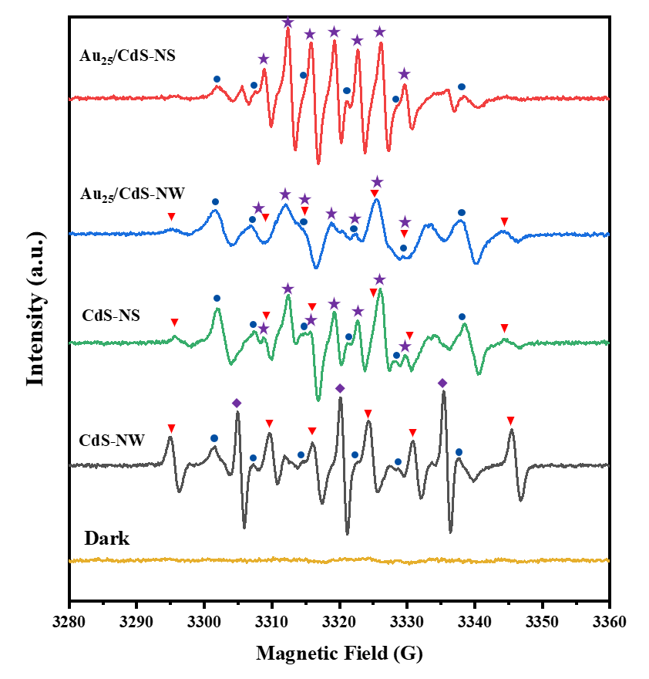

Fig. S5 EPR spectra of the different samples after the reaction. Triangle (red): ·CH(Ph)-OH (*A*N=14.61G, *A*H=21.40G); rhombus (purple): species from DMPO (self-)oxidation (*A*N=15G); star (purple): species from DMPO (self-)oxidation in CH3CN, (*A*N=6.88G, *A*H=3.46G); circle (blue): PhCH2O· (*A*N=13.6G, *A*H=7.5G).

The samples after the reaction under illumination showed one or two types of radical from BzOH except that from DMPO, namely ·CH(Ph)-OH derived from the elimination of the α-H in BzOH, and PhCH2O· obtained from the elimination of the H in −OH of BzOH. The ·CH(Ph)−OH and PhCH2O· was dominated in the CdS-NW and CdS-NS, respectively. Upon the loading of Au25, the PhCH2O· radical turned to be dominant in Au25/CdS-NW, together with some minor ·CH(Ph)−OH. For the Au25/CdS-NS, the ·CH(Ph)−OH even totally disappeared, leaving PhCH2O· as the sole radical derived from BzOH.



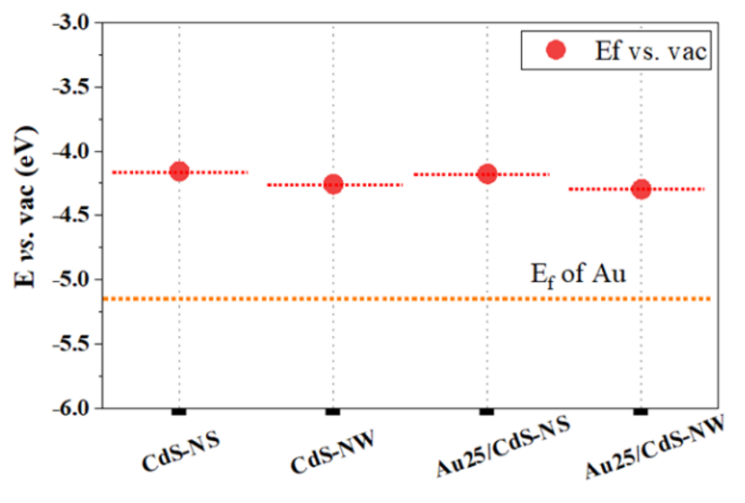

Fig. S6 The comparison of the Fermi levels among the samples as indicated. The Fermi levels were determined by the Mott-Schottky plots.