Supporting Information

**Multi-site Co2P catalyst derived from soybean biomass for dehydrogenation of formic acid**

**WANG Bixi1,2, LIU Zeyu2, WU Yabei1, YANG Yanyan1,*, YANG Song2,**

**WANG Xun3,4, YE Zi5, DONG Hongliang5, ZHU Feng1,**

**YU Huanhuan1, LÜ Yingying1, YU Zhongliang1,\***

1School of Chemistry and Environmental Sciences, Shangrao Normal University, Shangrao 334001, China;

2College of Chemical Engineering and Technology, Taiyuan University of Technology, Taiyuan 030024, China;

3College of Safety and Emergency Management Engineering, Taiyuan University of Technology, Taiyuan 030024, China;

4Shanxi Coking Coal Group Co. LTD, Taiyuan 030024, China;

5Center for High Pressure Science and Technology Advanced Research, Shanghai 201203, China

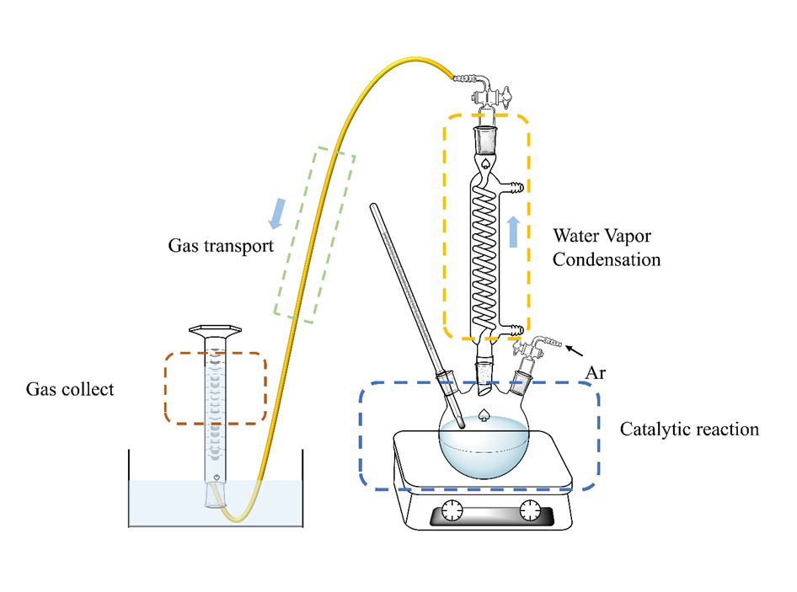

Fig. S1 Experimental apparatus of hydrogen generation from formic acid dehydrogenation



Fig. S2 Nitrogen adsorption-desorption isotherm and BJH pore size distribution of soybean-derived C support and (Co2P)1-SB15



Fig. S3 P 2*p* XPS spectra of carbon material obtained by direct pyrolysis of soybean



Fig. S4 (a) XRD patterns of (Co2P)1-SB10 synthesized at different pyrolysis temperatures; (b) XRD patterns of catalysts synthetized at 750 oC; (c) Effect of FA concentration on volume of product gas with (Co2P)1-SB15 catalyst; (d) XRD patterns of the (Co2P)1-SB15 catalyst after 1st and 5th run

**Table S1** Comparison of FAD over various Co-based heterogeneous catalysts

|  |  |  |  |  |  |
| --- | --- | --- | --- | --- | --- |
| Catalyst | Temperature (℃) | Gas production rate(mL/g/h) | Solvent | FA concentration (mol/L) | References |
| Co(1)/phen(7)/C | 98 | 423.3 | propylene carbonate | 1.57 | [1] |
| Co-N-C (SACs) | 98 | 319.2 | propylene carbonate | 1.57 | [2] |
| (Co2P)1-SB15 | 98 | 237.47 | H2O | 10 | this work |
| Co-N-C (NPs) | 98 | 229.2 | propylene carbonate | 1.57 | [2] |
| Co-N-C (NPs) | 88 | 195.8 | H2O | 1.57 | [2] |
| Co-N-C (SACs) | 88 | 167.9 | H2O | 1.57 | [2] |
| Co@NC-Gr2 | 95.5 | 124 | o-xylene | 1.24 | [3] |
| Co(1)/phen(2)/C | 95~100 | 92.4 | H2O | 1.57 | [1] |

**References**

[1] Tang C, Surkus A E, Chen F, et al. A stable nanocobalt catalyst with highly dispersed CoN*x* active sites for the selective dehydrogenation of formic acid[J]. Angew Chem Int Ed, 2017, 129(52): 16843−16847.

[2] Li X, Surkus A E, Rabeah J, et al. Cobalt single‐atom catalysts with high stability for selective dehydrogenation of formic acid[J]. Angew Chem Int Ed, 2020, 59(37): 15849−15854.

[3] Chernov A N, Astrakova T V, Sobolev V I, et al. Liquid versus gas phase dehydrogenation of formic acid over Co@ N-doped carbon materials. The role of single atomic sites[J]. Mol Catal, 2021, 504: 111457.